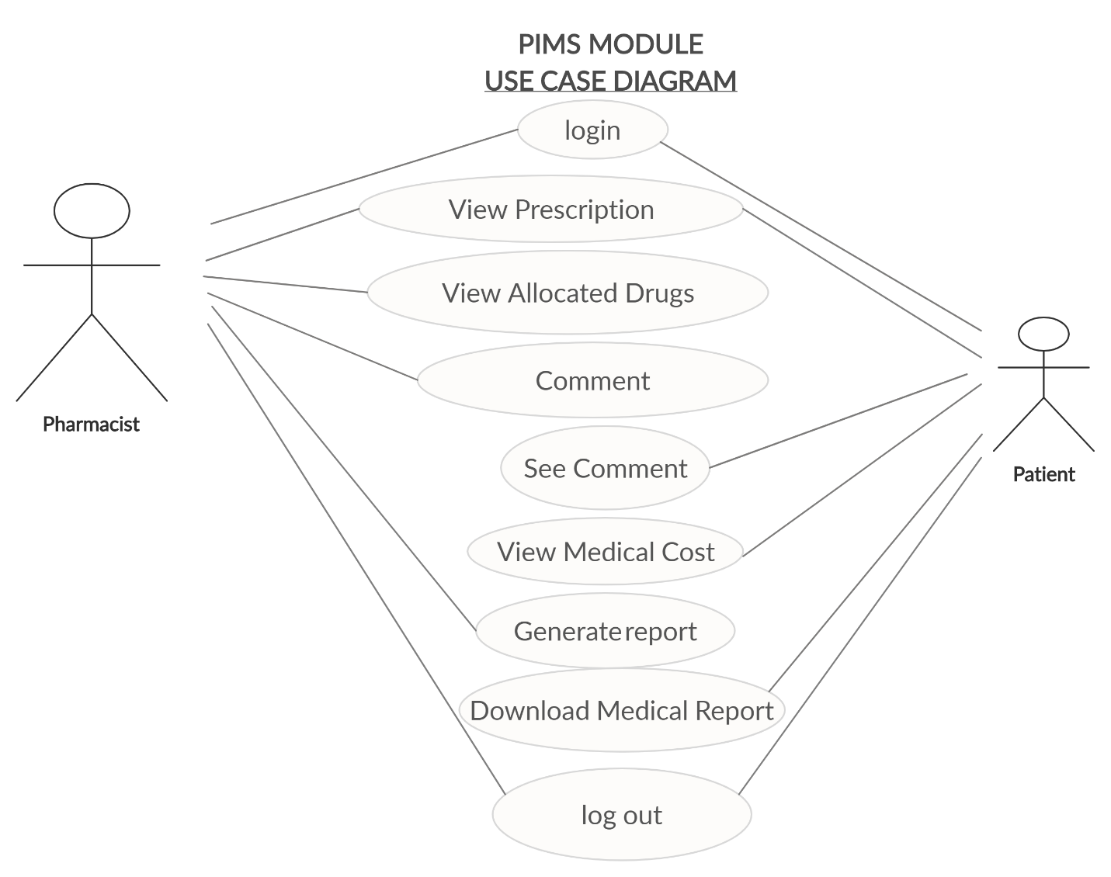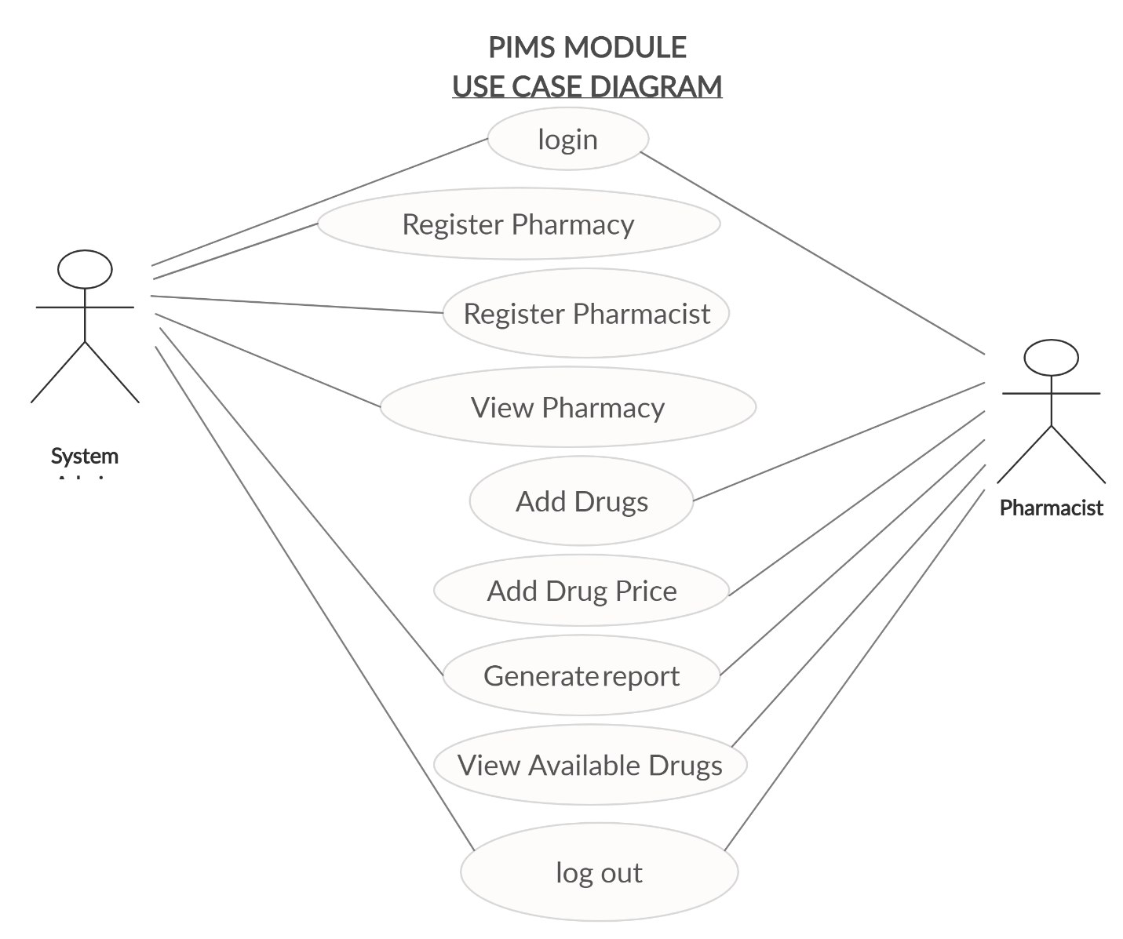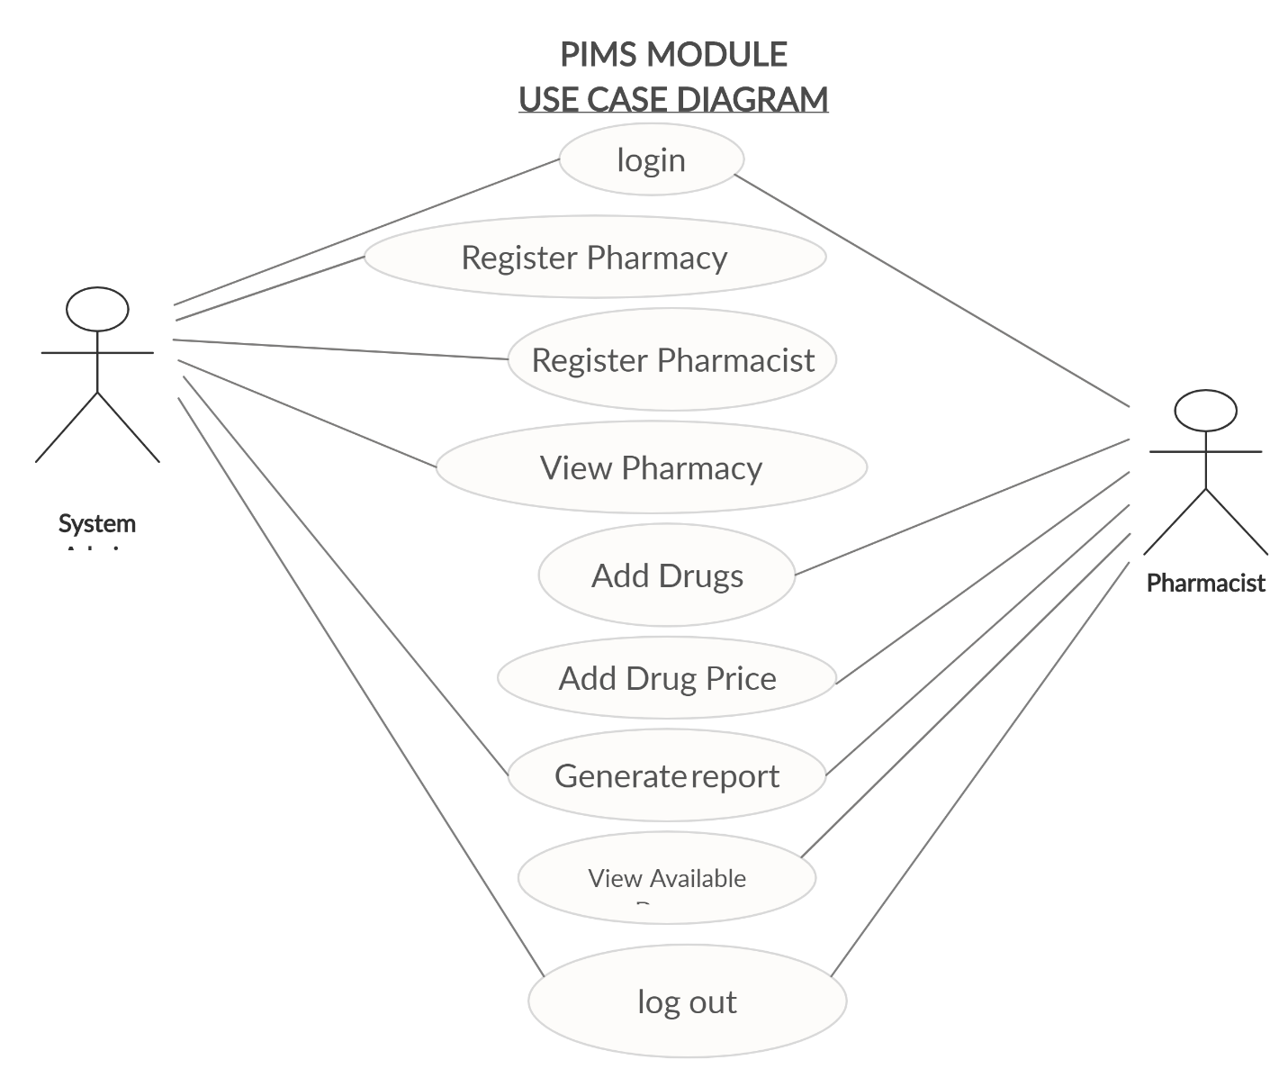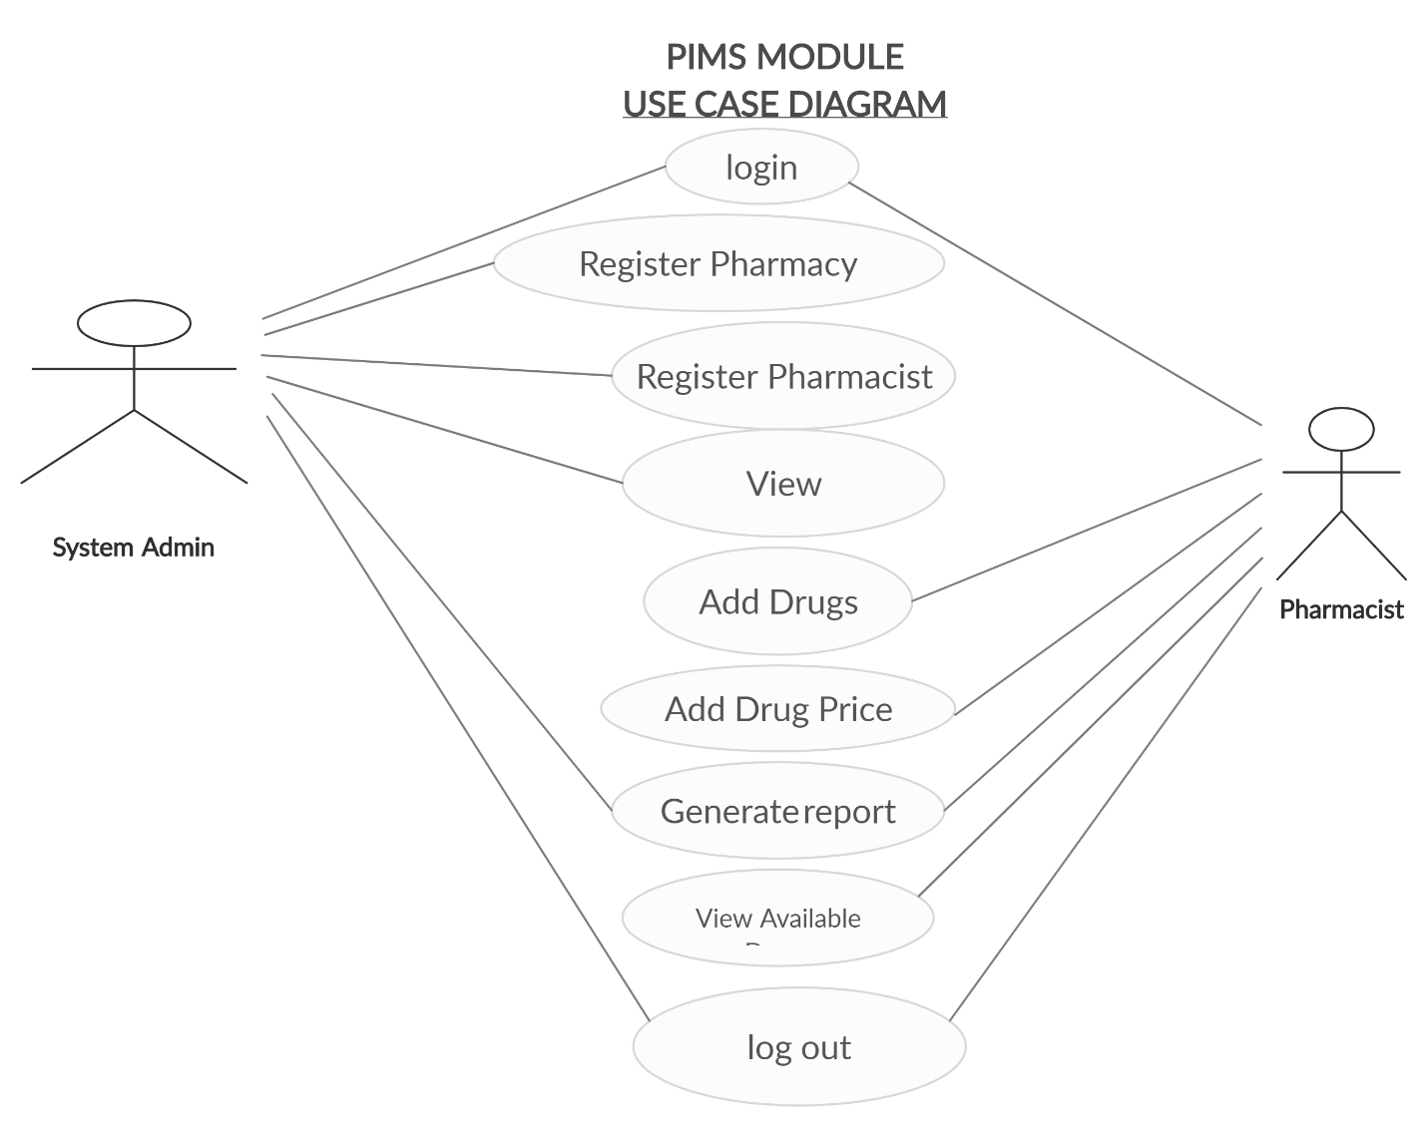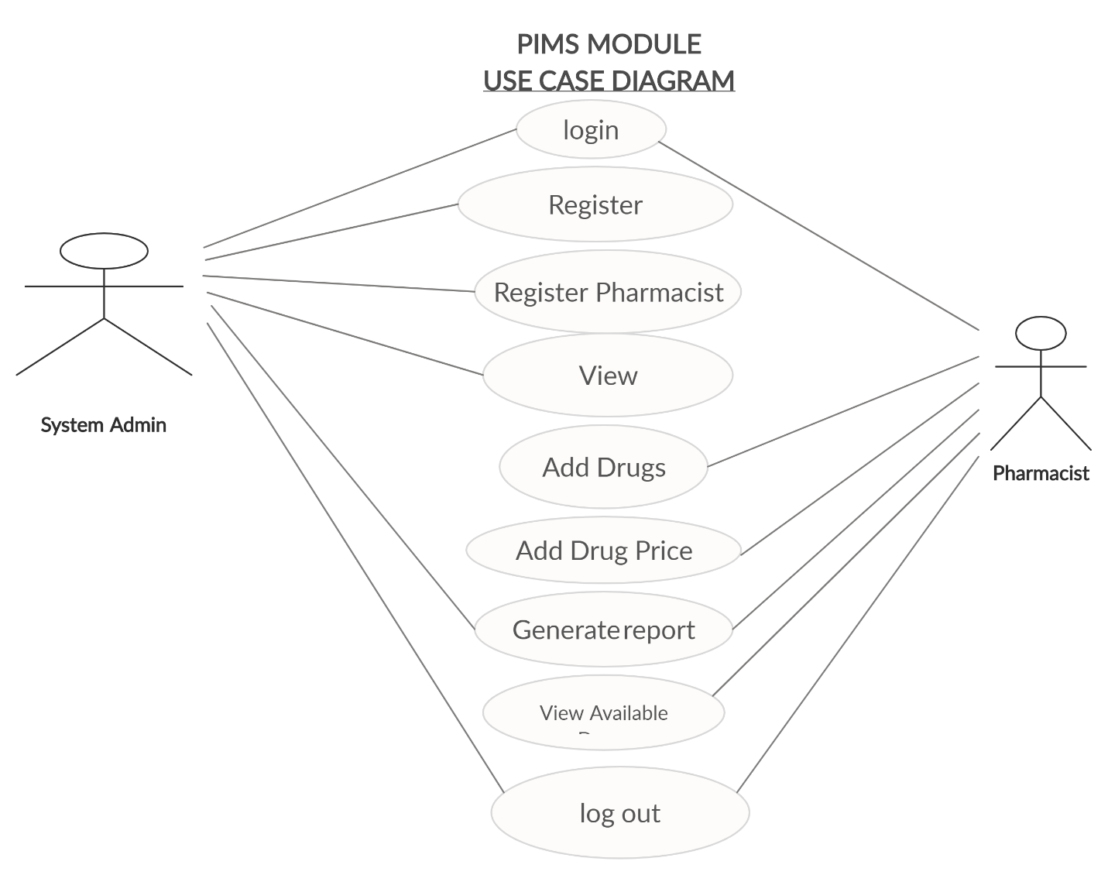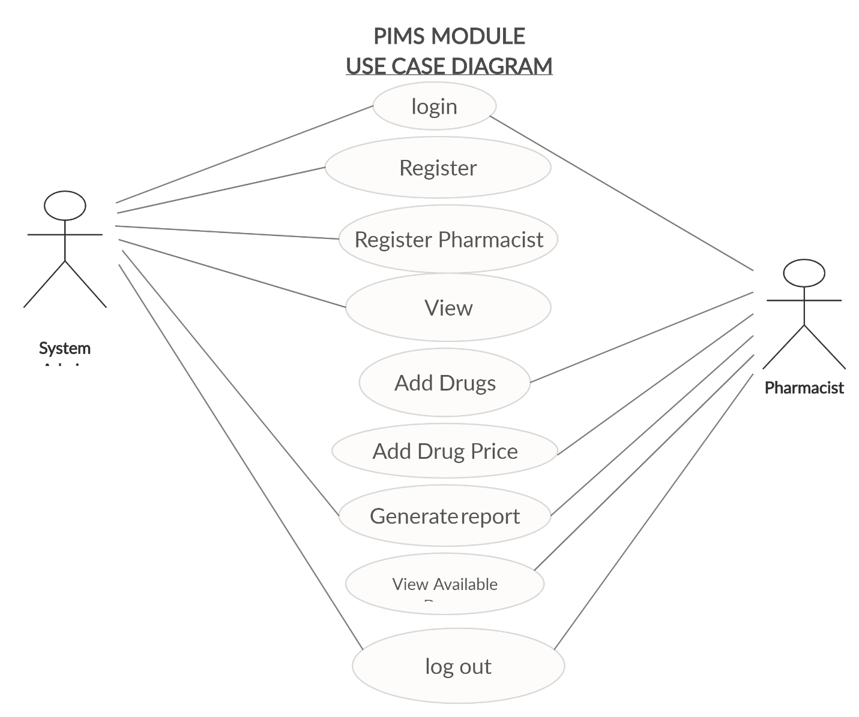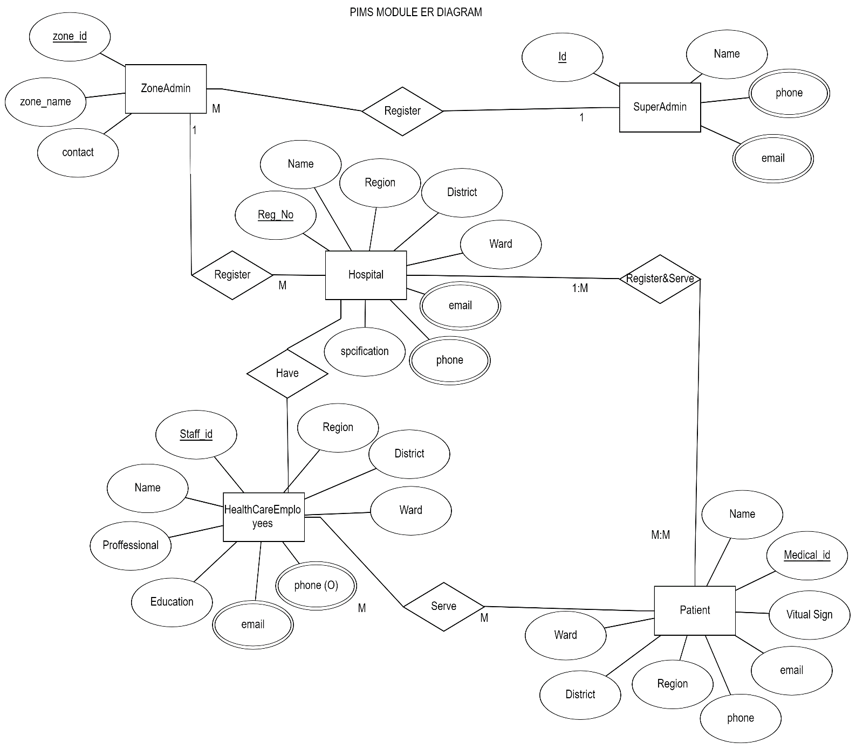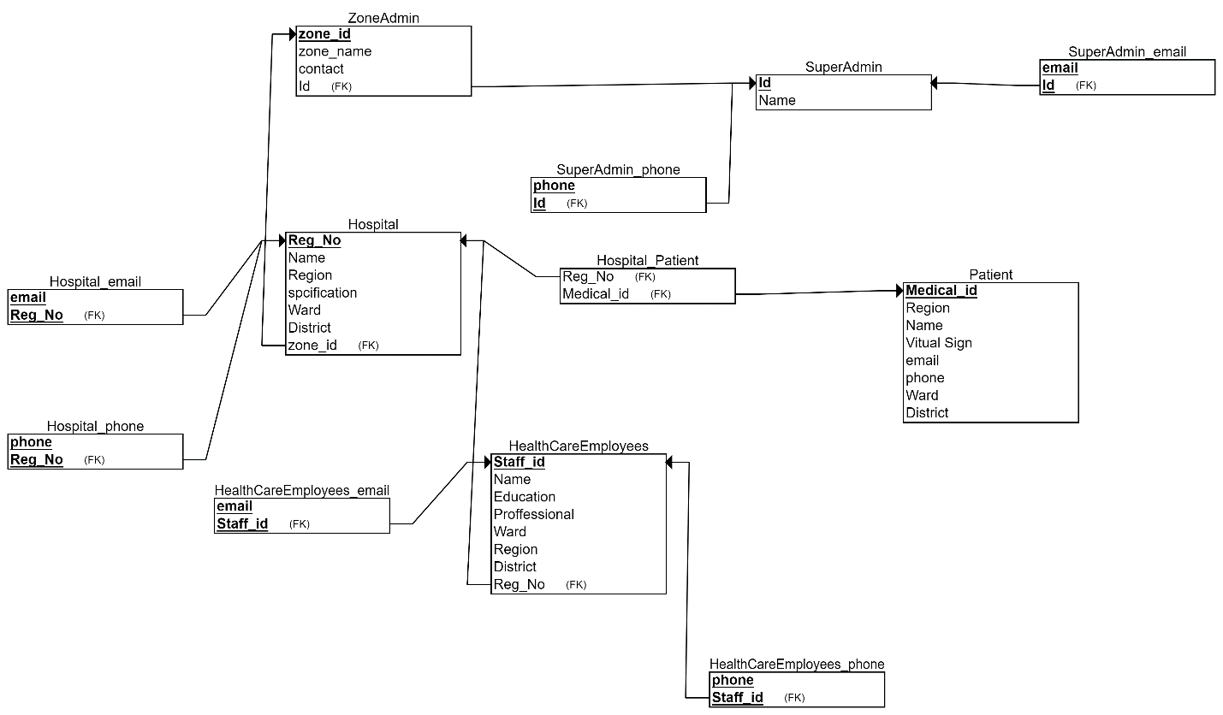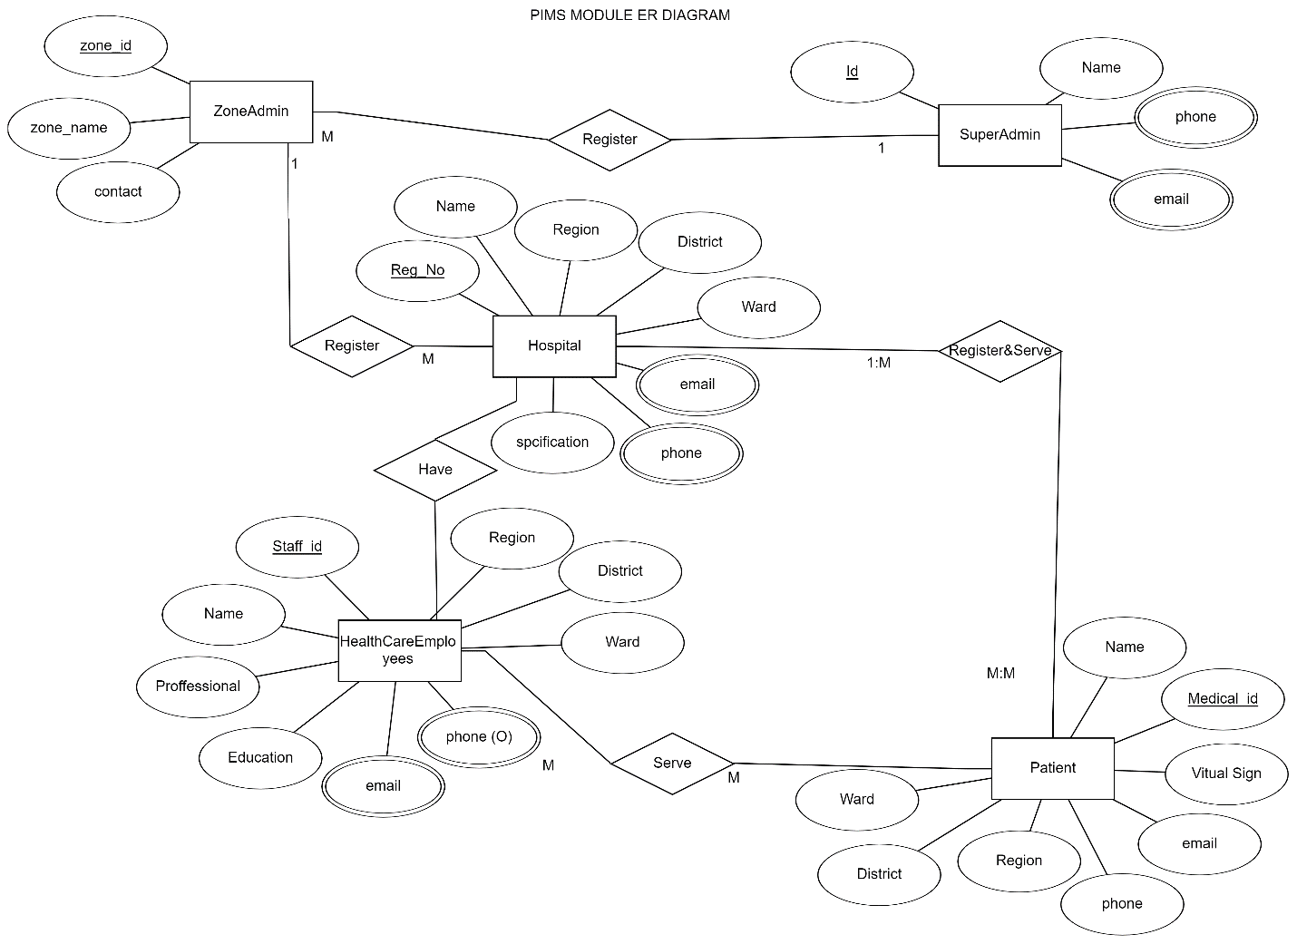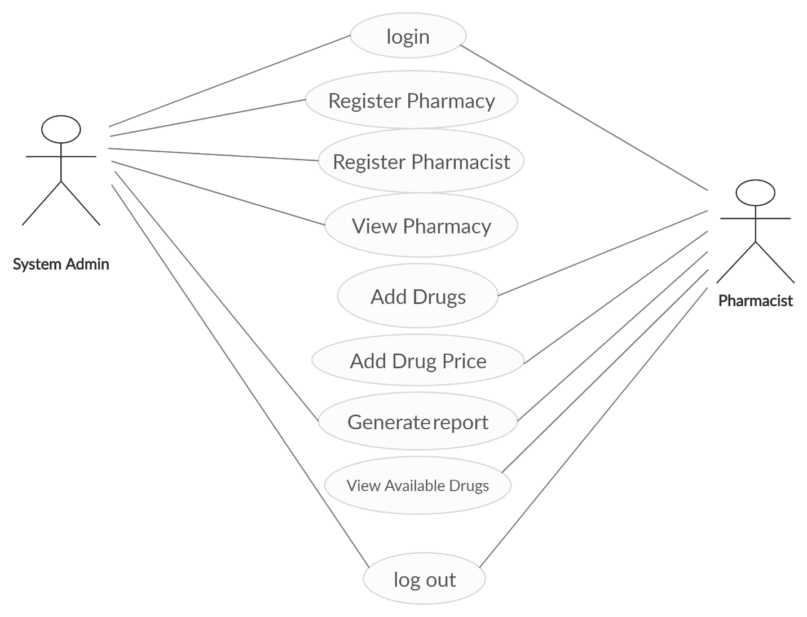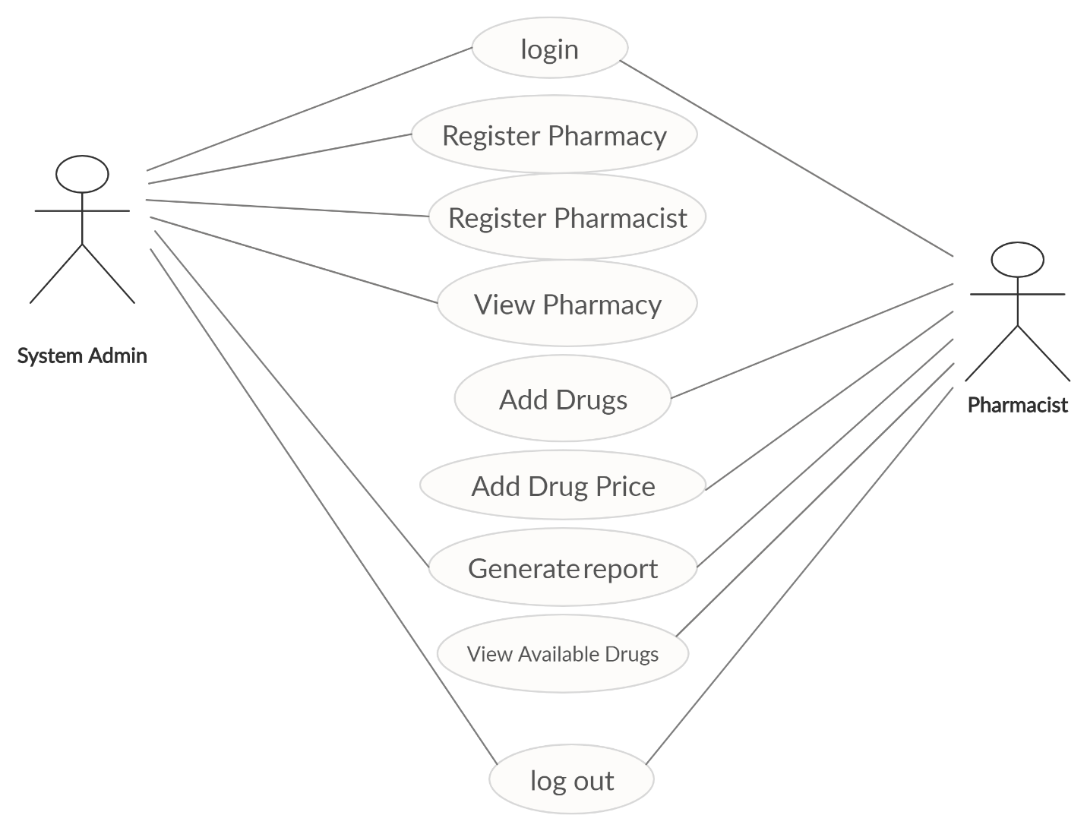

CREATE TABLE SuperAdmin

(

Id VARCHAR NOT NULL,

Name CHAR NOT NULL,

PRIMARY KEY (Id)

);

CREATE TABLE Patient

(

Region VARCHAR NOT NULL,

Name VARCHAR NOT NULL,

Medical_id VARCHAR NOT NULL,

Vitual_Sign VARCHAR NOT NULL,

email VARCHAR NOT NULL,

phone VARCHAR NOT NULL,

Ward VARCHAR NOT NULL,

District VARCHAR NOT NULL,

PRIMARY KEY (Medical_id)

);

CREATE TABLE SuperAdmin_phone

(

phone VARCHAR NOT NULL,

Id VARCHAR NOT NULL,

PRIMARY KEY (phone, Id),

FOREIGN KEY (Id) REFERENCES SuperAdmin(Id)

);

CREATE TABLE SuperAdmin_email

(

email VARCHAR NOT NULL,

Id VARCHAR NOT NULL,

PRIMARY KEY (email, Id),

FOREIGN KEY (Id) REFERENCES SuperAdmin(Id)

);

CREATE TABLE ZoneAdmin

(

zone_id VARCHAR NOT NULL,

zone_name CHAR NOT NULL,

contact INT NOT NULL,

Id VARCHAR NOT NULL,

PRIMARY KEY (zone_id),

FOREIGN KEY (Id) REFERENCES SuperAdmin(Id)

);

CREATE TABLE Hospital

(

Reg_No VARCHAR NOT NULL,

Name VARCHAR NOT NULL,

Region VARCHAR NOT NULL,

spcification VARCHAR NOT NULL,

Ward VARCHAR NOT NULL,

District VARCHAR NOT NULL,

zone_id VARCHAR NOT NULL,

PRIMARY KEY (Reg_No),

FOREIGN KEY (zone_id) REFERENCES ZoneAdmin(zone_id)

);

CREATE TABLE HealthCareEmployees

(

Name VARCHAR NOT NULL,

Education VARCHAR NOT NULL,

Proffessional VARCHAR NOT NULL,

Staff_id VARCHAR NOT NULL,

Ward VARCHAR NOT NULL,

Region VARCHAR NOT NULL,

District VARCHAR NOT NULL,

Reg_No VARCHAR NOT NULL,

PRIMARY KEY (Staff_id),

FOREIGN KEY (Reg_No) REFERENCES Hospital(Reg_No)

);

CREATE TABLE Hospital_email

(

email INT NOT NULL,

Reg_No VARCHAR NOT NULL,

PRIMARY KEY (email, Reg_No),

FOREIGN KEY (Reg_No) REFERENCES Hospital(Reg_No)

);

CREATE TABLE Hospital_phone

(

phone VARCHAR NOT NULL,

Reg_No VARCHAR NOT NULL,

PRIMARY KEY (phone, Reg_No),

FOREIGN KEY (Reg_No) REFERENCES Hospital(Reg_No)

);

CREATE TABLE HealthCareEmployees_email

(

email VARCHAR NOT NULL,

Staff_id VARCHAR NOT NULL,

PRIMARY KEY (email, Staff_id),

FOREIGN KEY (Staff_id) REFERENCES HealthCareEmployees(Staff_id)

);

CREATE TABLE HealthCareEmployees_phone

(

phone VARCHAR NOT NULL,

Staff_id VARCHAR NOT NULL,

PRIMARY KEY (phone, Staff_id),

FOREIGN KEY (Staff_id) REFERENCES HealthCareEmployees(Staff_id)

);

CREATE TABLE Hospital_Patient

(

Medical_id VARCHAR NOT NULL,

Reg_No VARCHAR NOT NULL,

FOREIGN KEY (Medical_id) REFERENCES Patient(Medical_id),

FOREIGN KEY (Reg_No) REFERENCES Hospital(Reg_No)

);

